**MEASURING SUCCESS IN TALENT MANAGEMENT**

**INTRODUCTION:**

Talent management includes all the ways that organizations bring employees on board, keep them happy and productive, and help them continue to develop to their skills over time.

**EMPATHY MAP**

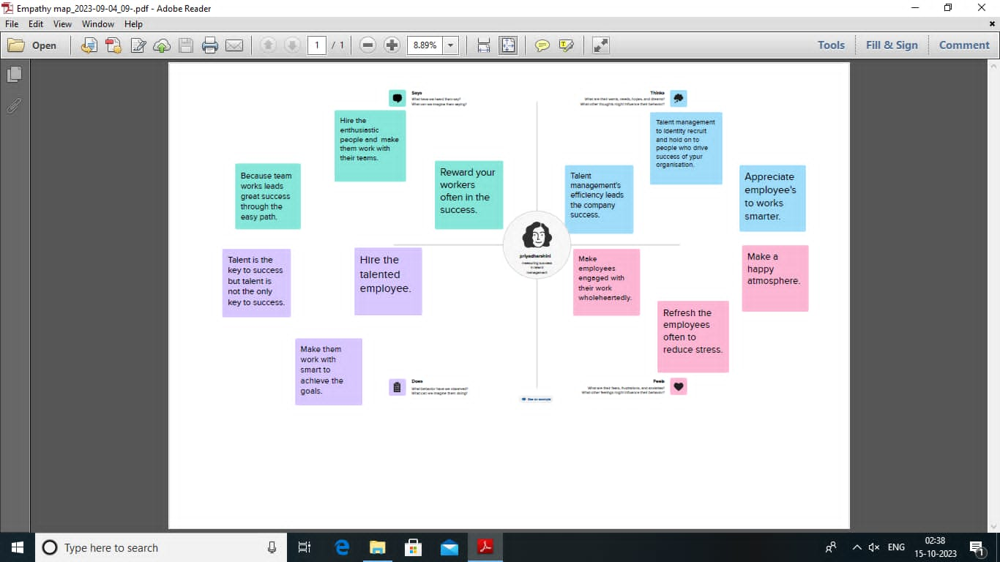

**BRAINSTORMING**

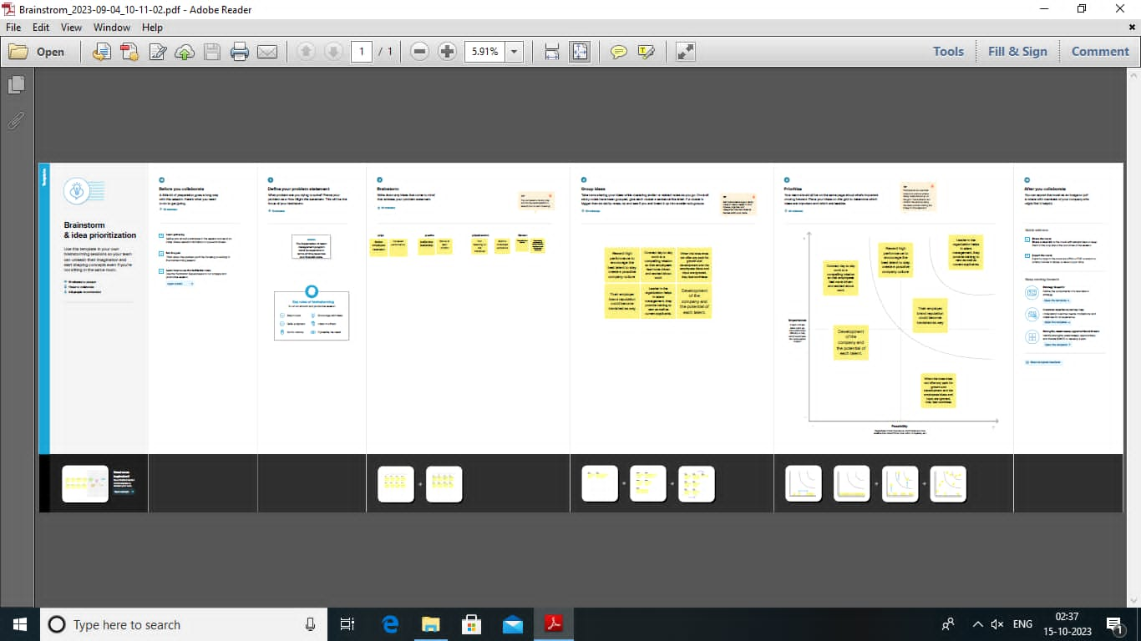

**RESULT:**

1. We have taken a dataset and we analysis the data by using tableau.

2. Tableau is the most powerful, secure, and flexible end-to-end analytics platform for your data. Elevate people with the power of data.

3. Designed for the individual, but scaled for the enterprise, Tableau is the only business intelligence platform that turns your data into insights that drive action.

**DASHBOARD**

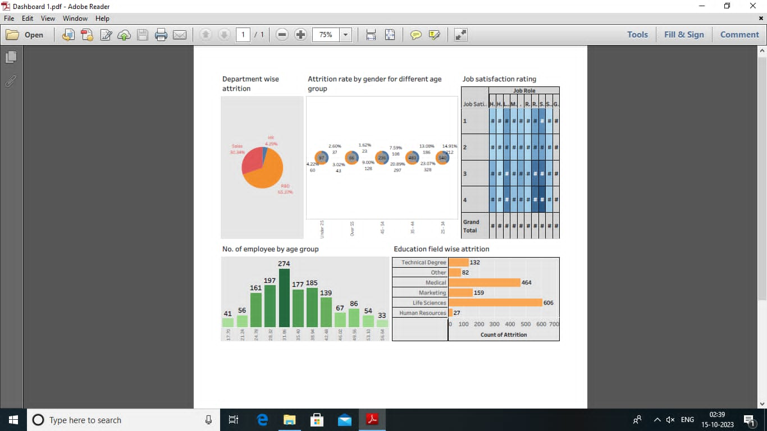

**STORY**

